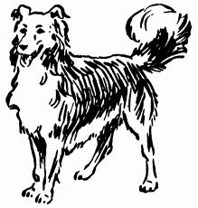Jackson County 4-H Skill-A-Thon
2020 DOG STUDY GUIDE

DIGESTIVE SYSTEM:

DID YOU KNOW:

Obesity is the most common nutritional disorder in pet dogs in the US.

6 essential nutrients for
Dogs Protein Fat
Carbohydrates Vitamins Minerals WATER
“What one do you think is
the most important?


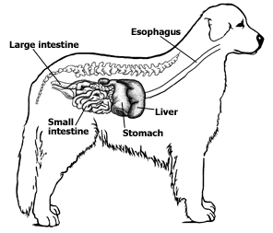
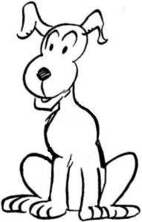
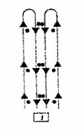
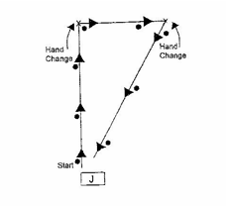
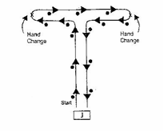
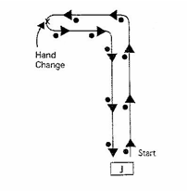
Learn to identify and understand showmanship patterns:

“Pair Gaiting” or “Triangle to the Right” “T Pattern to the Left” “L Pattern to the Left”

“Down & Back Together

1 | P a g e

Parts of a
Dog
It is important to be able to identify
the parts of your
4-H animals. Study this picture and practice identifying the parts.

DID YOU KNOW:

Parasites that Dogs can get:
A dog’s height is measured from the ground to the highest point of his withers.

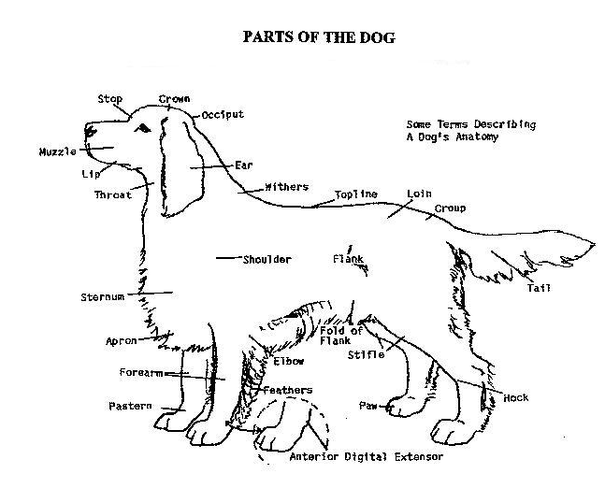

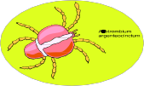
INTERNAL EXTERNAL Hookworms Flea Heartworms Louse Whipworms Mite Roundworms Tick Tapeworms

What are the diseases covered by the DHLPP vaccination?_

2 | P a g e



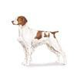
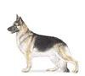
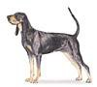
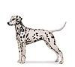
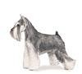
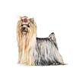
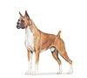
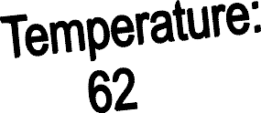








Knowing the names and a few characteristic of
different breeds of Dogs is important.

Match the AKC breeds of
Dogs with the pictures.

A. B. C. D.
E.

F.

G.

German Shepard: This dog is from Germany and derived from the oldest breeds of herding and farm dogs. It is approachable and fearless with a strong, muscular body. The German Shepard is hailed as the world’s leading police, guard and military dog.

Bloodhound: This is one of the few All-American breeds. It is a persistent, determined, honest hunter who will stay on track no matter the terrain or conditions. Their coat is thick and skin is loose.

Yorkshire Terrier: These dogs were named from an English city in the 19th century where they were bred to catch rats in clothing mills. Originally a working dog, they left the workforce to become
companions to families because of their compact size and neatness.

Brittney: The Brittany is from France. It is a medium-sized, dual purpose dog suited for sport and companionship. It is a talented hunting and show dog. They were bred to hunt small game and fowl.

Dalmatian: This alert and active dog is the only spotted breed. It has great endurance, speed and intelligence. They are used as a family pet or for performance. He has a basic instinct for horse companionship, making him a guardian of the horse-drawn.

Boxer: The Boxer is a loving, intelligent, powerful dog with and alert expression. They have an instinctive guardian attitude and used as couriers during war time and as seeing-eye dogs for the blind. They are fawn and brindle colors and rank as one of the most popular dogs.

Miniature Schnauzer: The Miniature Schnauzer has whiskers and double coat of hard and wiry outer coat with a close, soft undercoat. He is small but loud and can give an alarm like a larger dog. He was originally bred to be a small farm dog to hunt for vermin.

3 | P a g e

Know the names and a few characteristic of different breeds of cattle:
Angus: These animals are polled (no horns) with a black coat. They are know for their carcass quality, milking and mothering and their reproductive traits.
They are the most popular breed of cattle in the United
stated.
Herford; These animals are red with white faces and
can be polled or horned. They were brought the United Stated in 1817. They became popular due to their hardiness, feed efficiency and disposition.
Simmental: Charolais Gelbvieh Limousin

Definitions:
Bull: Male animal
Heifer: Female animal that has not yet calved
Steer: Castrated male
Fattening: The process of deposition energy in the form of
fat within the body tissue
Gestation: The length of time an animal is pregnant Cud: The bolus of eaten feed which is regurgitated and further chewed.
Expenses: items that you have purchased for your project
Profit: when your income is larger than your expenses Loss: when your expenses are larger than your income
Breakeven: The price per pound you need to cover your total expenses
Intravenous-applying medication for the benefit of the animal directly into the blood flow
Subcutaneous: Applying medication for the benefit of the animal under the skin
Intramusclar: applying medication for the benefit of the
animal into the muscle

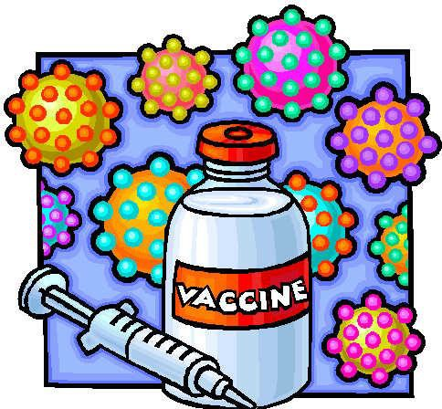
American Kennel Club (AKC) Dog Breed Groups

Dog breeds are grouped according to similar use or purpose!

DHLPP stands for what vaccination that your dog needs?

o Distemper
o Hepatitis
o Leptospirosis
o Parvo
o Para influenza
Sporting Dogs Hounds Working Dogs Terriers
Toys
Non-Sporting
Herding Dogs

Dog Conformation

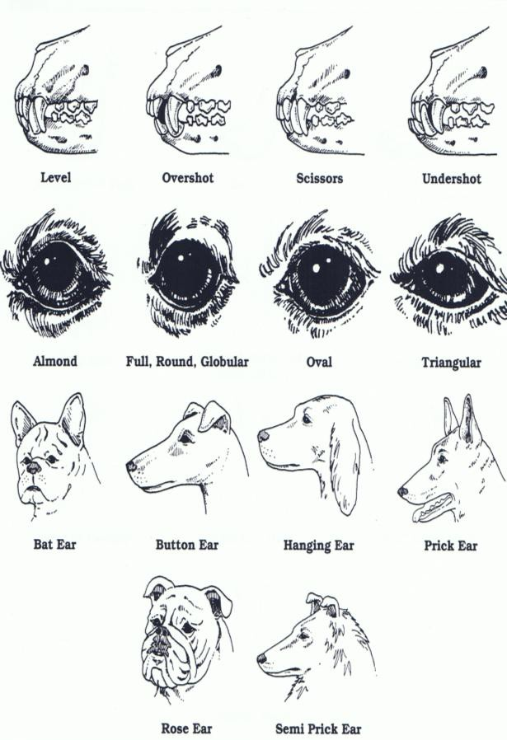
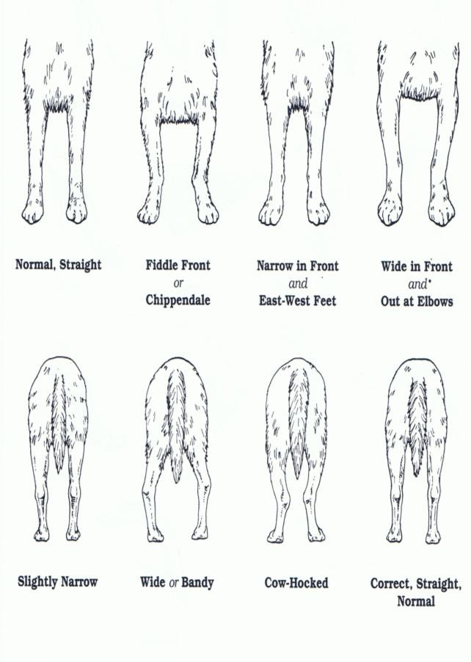
Bites, Ears and Eyes Front and Rear Legs

4 | P a g e

Backlines Feet, Pasterns, and Stifles

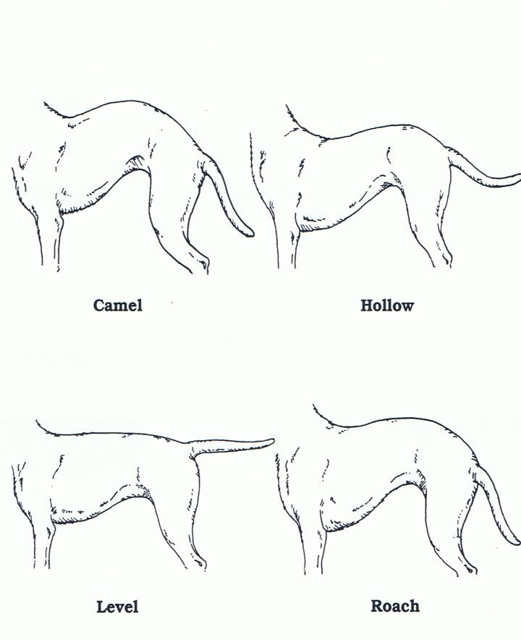
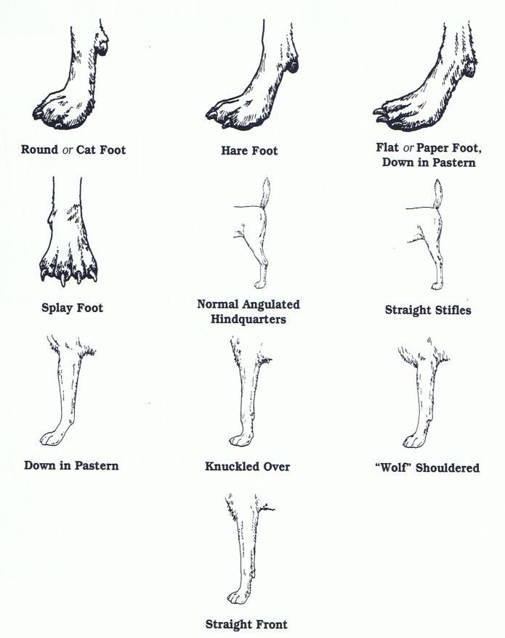
Definitions:

Gait: Moving a dog at a trot in a specified pattern.

Stack: Position a dog’s legs and body according to its breed recommendations.
Breed Group: A collection of breeds with a similar use or purpose. Hip dysplasia: Disorder of the hip joint where the hip ball is poorly
seated in the joint socket.

Quick: Living inner portion of a nail, with blood and nerve supply.

Tuck Up: Part of the dog’s body where the belly rises up to blend with
the hind quarters; where dog’s body narrows below its loin; its waist.

✓ Page 1: The most important Nutrient: Water
✓ Page 2: Distemper, Distemper, Hepatitis, Leptospirosis, Parvo, Para influenza

5 | P a g e

