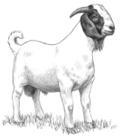
Jackson County 4-H Skill-A-Thon
2020 GOAT STUDY GUIDE

Name the four different compartments of the stomach of goat.
RUMINANT ANIMALS:
- A goat is a ruminant animal. They have four compartments to their stomach (rumen, reticulum, omasum, abomasum).
- Ruminant animals ruminate. Ruminating is when the animal regurgitates their feed, in what is called a “cud,” to further breakdown their feed with their teeth.
- Goat can eat roughages (hays) and concentrate (grains).
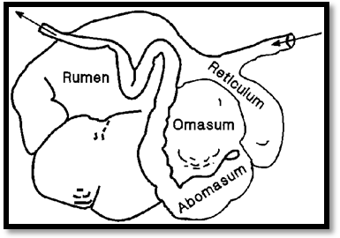

___________________________
___________________________
___________________________
DID YOU KNOW: Goats do not have teeth in their upper front jaw.
___________________________
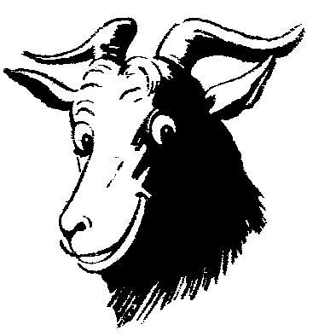

6 essential nutrients for Goats
Protein
Fat
Carbohydrates
Vitamins
Minerals
WATER
“What one do you think is the most important? _____________

Intermediate and Senior showman should know the parts of a hoof and tools used for trimming hooves.
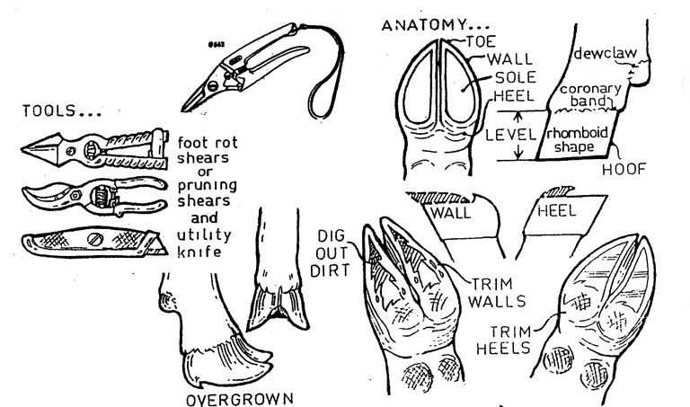

Wholesale Cuts of Lamb
Can you name cuts of meat that comes from each wholesale cut.
________________________________________________________________________________________________________________________________________________________________________________________________________________________________________________________________________________________________________________________________________________

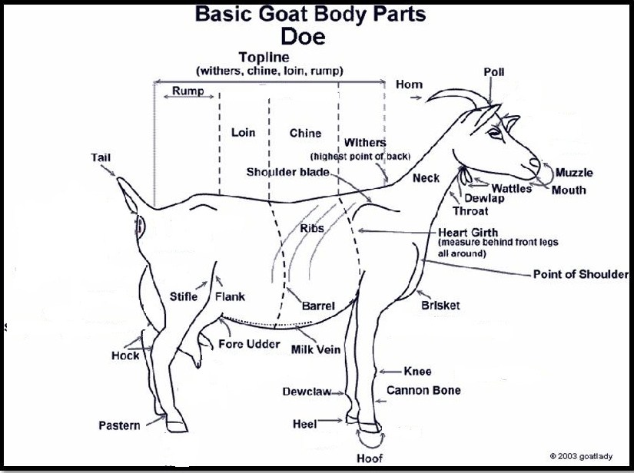
DID YOU KNOW: Chevon is a great source of protein for humans.

Parts of a Goat
It is important to be able to identify the parts of your 4-H animals. Study this picture and practice identifying the parts.


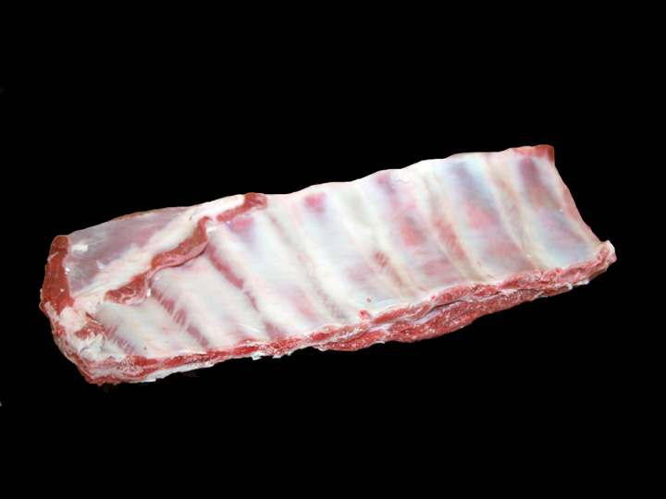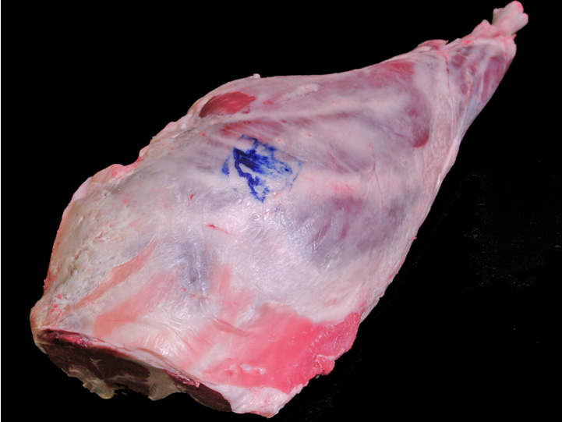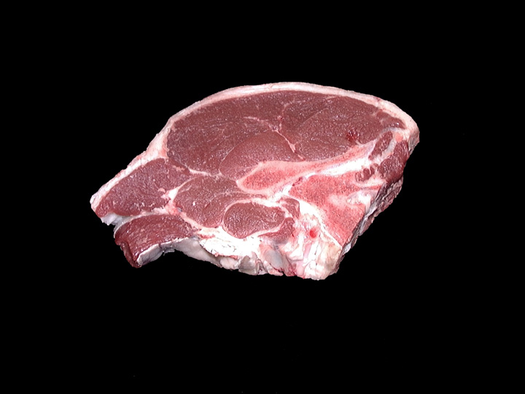
Breast, Denver Style Ribs Leg French Style Leg, Sirloin Chop

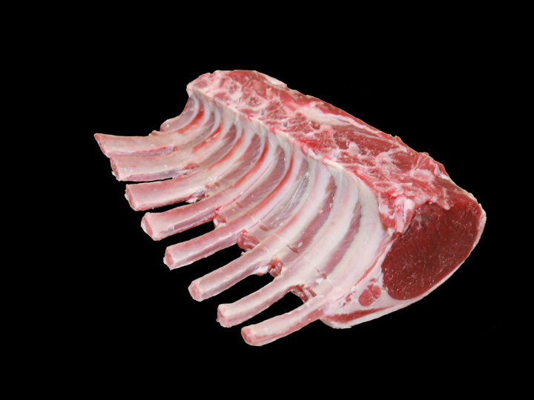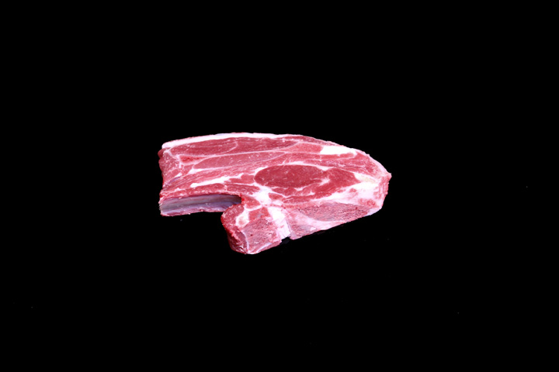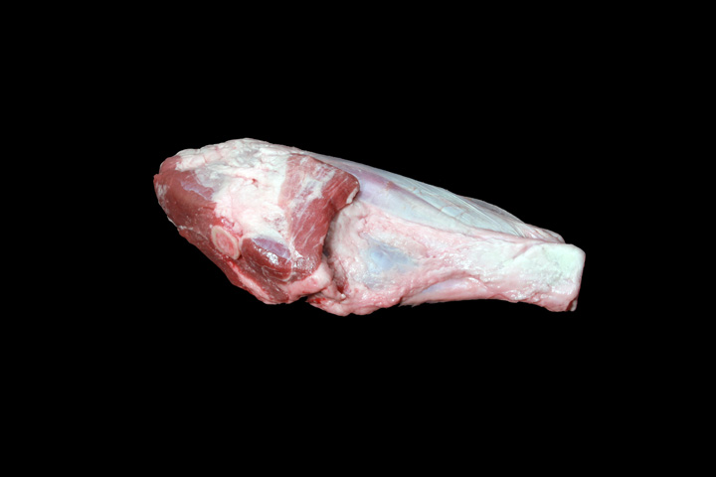
Rib, Rib Roast Frenched Shoulder,Blade chop Various, Shank

- Apline: These goats have upright ears, a straight face, and medium to short hair. All coat colors or combinations are acceptable. They are medium to large. They are alert and graceful. Origin- French Alps

- Boer: These goats are characterized by excellent early growth rates, high weaning weights, and early maturity. Boer goats are known for their mothering abilities, but are best known for the production of low-fat meat. Origin- South Africa

- Angora: Angora goats are the smallest of goat breeds. They have straight or concave nose; pendulous ears; and large, twisted horns. They are commonly white. Their long, upper coat is a fine and lustrous fiber. Origin- Turkey

- Pygmy: This dwarf breed of goats is short legged with a small compacted body. They are various colors. The head has a dish profile and a broad, well muscled jaw. These goats are hardy and alert. Origin- Western Africa

- Nubian: Nubian goats have a strong convex face profile, and long , bell shaped ears. They are known for their long breeding cycle, and their milk being high in protein and butterfat. Origin- England

Breeds of Goats

Know the names and a few characteristic of different breeds of cattle:
Angus: These animals are polled (no horns) with a black coat. They are know for their carcass quality, milking and mothering and their reproductive traits. They are the most popular breed of cattle in the United stated.
Knowing the names and a few characteristics of different breeds of Goats is important.
Herford; These animals are red with white faces and can be polled or horned. They were brought the United Stated in 1817. They became popular due to their hardiness, feed efficiency and disposition.
Match the breeds of goat with the pictures
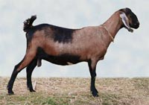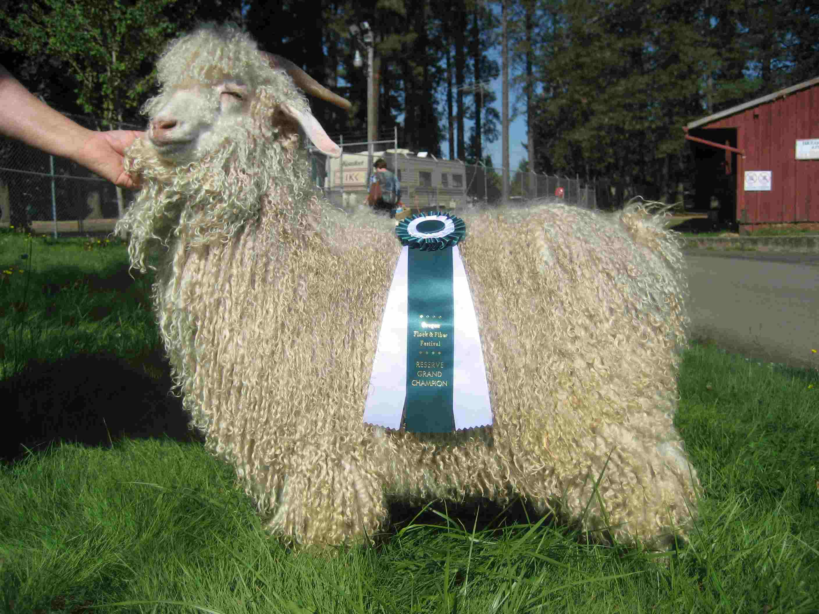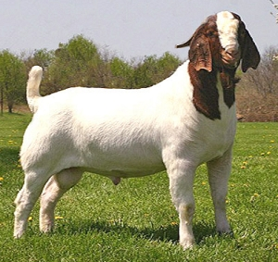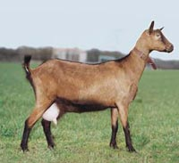
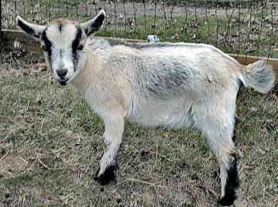
Simmental:
Charolais
Gelbvieh
Limousin

Definitions:
Bull: Male animal
Heifer: Female animal that has not yet calved
Steer: Castrated male
Fattening: The process of deposition energy in the form of fat within the body tissue
Gestation: The length of time an animal is pregnant
Cud: The bolus of eaten feed which is regurgitated and further chewed.
Expenses: items that you have purchased for your project
Profit: when your income is larger than your expenses
Loss: when your expenses are larger than your income
Breakeven: The price per pound you need to cover your total expenses

Intravenous-applying medication for the benefit of the animal directly into the blood flow
Subcutaneous: Applying medication for the benefit of the animal under the skin

Intramusclar: applying medication for the benefit of the animal into the muscle

Animal Health
It is very important to be able to monitor the health of your animal, know your vet and be able to properly treat the animal as need.
- Never give medication to your animal without a vet, parent or your 4-H leader.
- To properly give medication to animals you must be able to understand the medication label. Be able to identify:
  - Name of the drug
  - Name of the distributor
  - Storage instructions
  - Withdrawal time
  - Quantity of contents
  - Active ingredients
  - Cautions and warnings
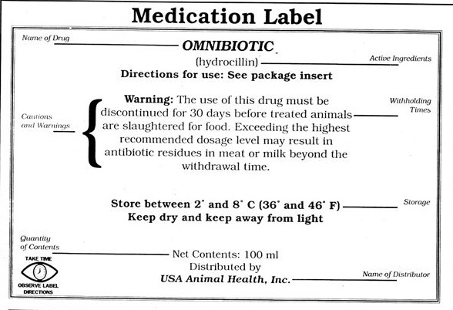
Feed

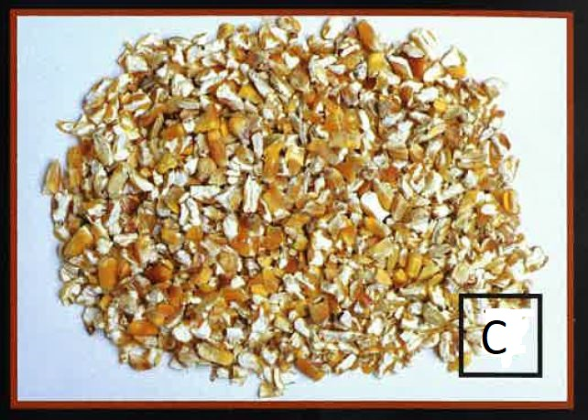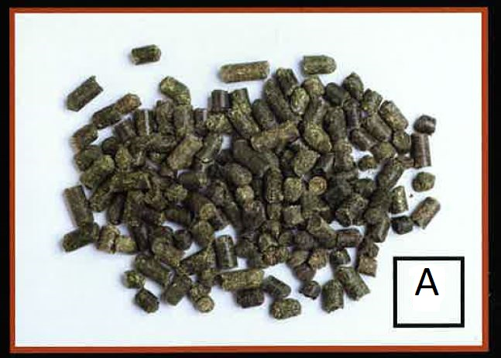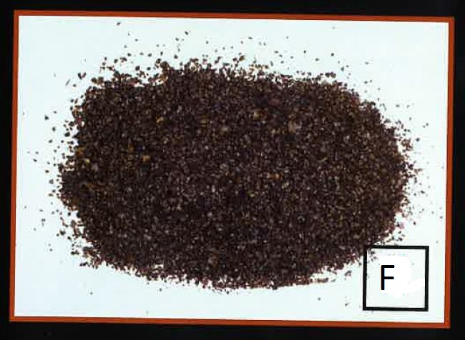
Cracked corn Alfalfa pellets dry molasses

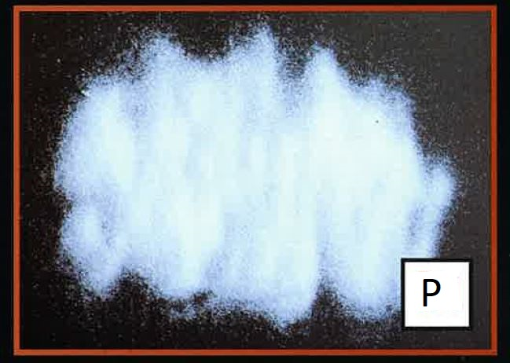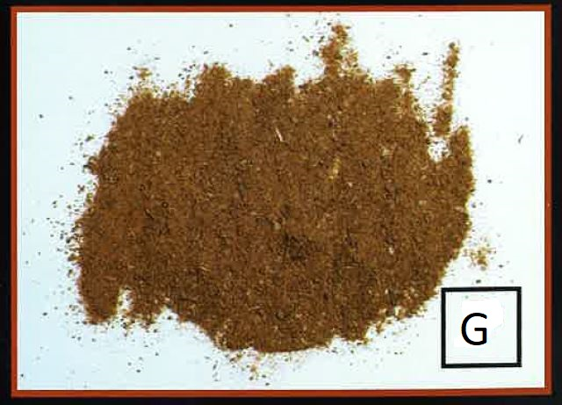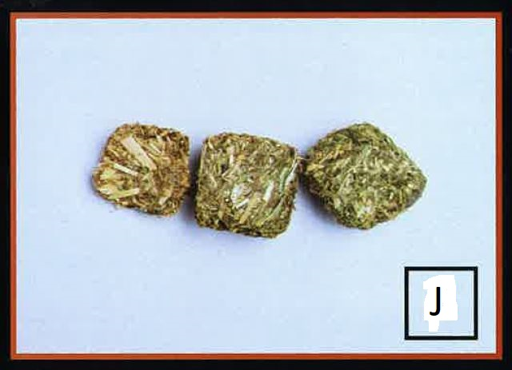
White salt fish meal hay cubes

Definitions:
Breakeven price: The price per pound you need to cover your total expenses.
Colostrum: The first milk that a kid gets from its mother. It is rich in nutrients and antibodies.
Chevon: Goat meat
Doeling; Female baby goat
Kids: Baby goats (either male or female)
Nanny: A mother goat.
Concentrate: High energy low fiber feeds (example: corn)
Conformation: The shape and design of an animal
Cud: The bolus of eaten feed which is regurgitated
Dressing Percent: The amount of meat on a carcass. The more meat the higher the cutability
Fattening: The process of depositing energy in the form of fat within the body tissue.
Gestation: The length of time a mother carries her kid.
Regurgitate: the process of bringing feedstuff from the stomach back up to the month to be re-chewed.
Roughage: High fiber low energy feeds (example: hay)
Ruminating: When the animal regurgitates their feed, in what is called a “cud,” to further breakdown their feed with their teeth.
Wether: Castrated male goat

- Page 1: Four compartments: Rumen, reticulum, omasum, abomasums ; The most important Nutrient: Water;
- Page 2: Wholesale cuts: shoulder, rack, loin, leg, foreshank and breast.
- Page 3: Breeds of Goat A. Nubian; B. Angora; C.Boer; D. Alpine; E. Pygmy.

