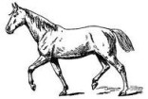
Jackson County 4-H Skill-A-Thon
2020 HORSE STUDY GUIDE
Answers are given on page 5

DIGESTIVE SYSTEM:

Horse’s have simple stomachs in their digestive system.

Their stomach is a relatively small stomach and most of the nutrient absorption occurs in the small intestine.

DID YOU KNOW that a
horse’s stomach can hold
8-17 quarts and their esophagus is 4-5 feet long.

6 essential nutrients for Horses Protein
Fat
Carbohydrates Vitamins Minerals WATER
“What one do you
think is the most important??


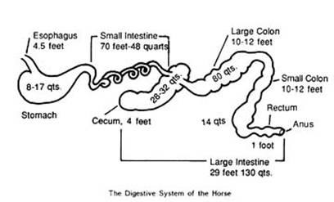
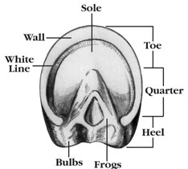
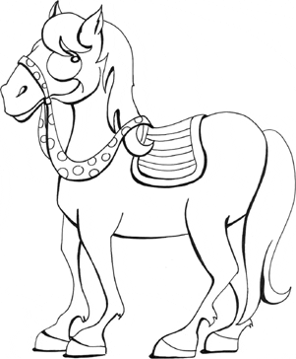

Intermediate and Senior 4-H members should be able to
label the parts of a horse’s hoof.

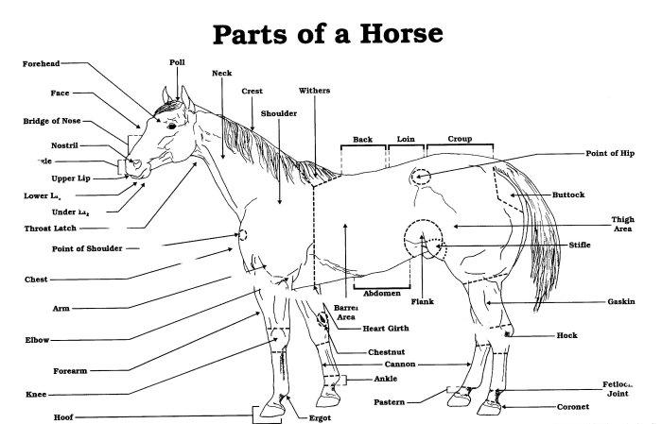
It is important to be able to identify the parts of your
4-H animals. Study this picture and practice identifying the parts.



General Tack and Equipment
You should be able to identify each piece of tack and equipment.

✓ Halter
✓ Hay bag
✓ Lunge Whip
✓ Curry Comb
✓ Saddle Bags
✓ Head Stall
✓ Feed Tub
✓ Bucket
✓ Horseshoe
✓ Leg Wrap
✓ Hoofpick
✓ Brush
✓ Hobbles
✓ Snaffle Bit
✓ Grooming Mit
✓ Girth
✓ Saddle

✓ Nose Band
✓ Bridle
✓ Medication Syringe
✓ Twitches
✓ Shedding Blade
✓ Bat
✓ Spurs
✓ Maine and Tail Comb
✓ Farrier Nippers
✓ Curb Bit
✓ Hoof Rasp
✓ Saddle Pad
✓ Breast Collar
✓ Lunge Line
✓ Combination Boot
✓ Bosal

Knowing the names and a few characteristics of
different breeds of horses is important.

Match the breeds of horses with the pictures.

A.

B.

C.

Appaloosa: This is a light breed that stands 14-2 to 15-2 hands. They are used for stock, pleasure, racing, parades, hunting, and jumping. They are identified with a spotted hind-end. Origin- Western United States

Thoroughbred: This horse stands 15 to 17 hands and is the largest of the light horse breeds. They were developed for racing due to their long legs, powerfully muscled hindquarters and long strides. Origin- England

Quarter Horses: This breed stands 15 to 16 hands and is powerfully built with strong hindquarters. They are used for racing, roping, hunting, jumping, and pleasure riding. Origin- United States



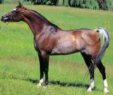
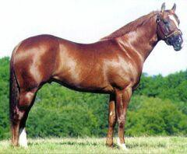
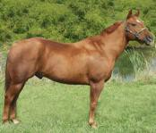
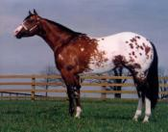
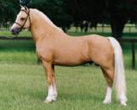
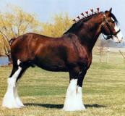
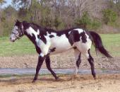









Definitions:
Boar: Male animal
Gilt: Female animal that has not yet farrowed
Barrow: Castrated male
Fattening: The process of deposition energy in the form of fat within the body tissue
Gestation: The length of time an animal is pregnant
Farrow: The process of giving birth
Arabians: This breed is known as the father of light horses. They stand 14-2 to 15-2 hands. They are used as stock,
D. pleasure, racing, and show horses. Origin- Arabian peninsula

Palomino: Palominos are classified by their color.
E. They stand 14-2 to 15-2 hands. Coats must be golden and their mane and tail are white, silver or ivory. Origin- Spain

American Paint: This breed is classified by its color. They are
F. splashed with a two-tone pattern of white with one additional color all over the body. Origin- United States

G. Clydesdale: This is a draft horse breed that is generally bay or brown with white markings. Their lower legs are extremely
feathery. They are used for exhibitions, special attractions, and farm work. Origin- Scotland

3 | P a g e

Definitions you should know

Colt: A male horse under 3 years old
Concentrate: High energy feed that is low in fiber (example: barley) Conformation: The shape and design of an animal
Ferrier: a person that is trained to shoe a horse and trim its hooves
Filly: A female horse under 3 years old
Foal: A baby horse
Gaits: The different speeds a horse can travel (walk, trot, canter, and gallop)
Gelding: Castrated male horse
Gestation: The length of time a mare carries a foal.
Hand: The unit used to measure the height of a horse (1 hand=4 inches)
Mare: Female horse
Roughage: Feed that is high in fiber and low in energy (example: hay)
Stallion: Male Horse

✓ Page 1: The most important nutrient: Water;
✓ Page 3: Breeds of Horses A. Arabian; B. Thoroughbred; C. Quarter Horse; D. Appaloosa; E Palomino; F.
Clydesdale; G. American Paint.

Animal Health
It is very important to be able to monitor the health of your animal, know your vet and be able to properly treat the animal as needed.
- Never give medication to your animal without a vet, parent or 4-H leader.
- To properly give medication to animals you must be able to understand the medication label.
Be able to identify:
  - Name of Drug
  - Name of distributor
  - Storage instructions
  - Withdrawal times
  - Quantity of content
  - Active ingredients
  - Cautions and warnings

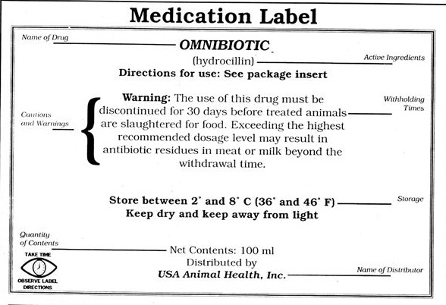

Feed

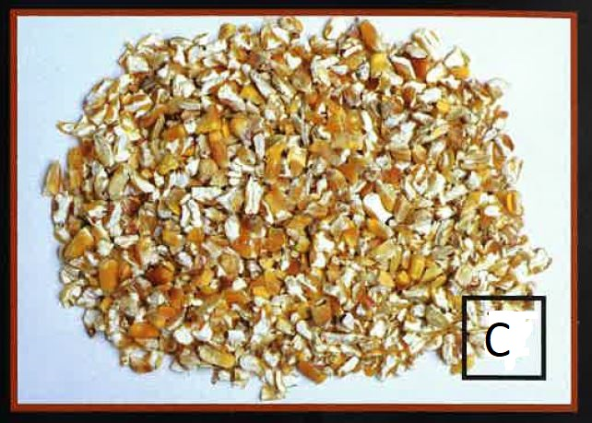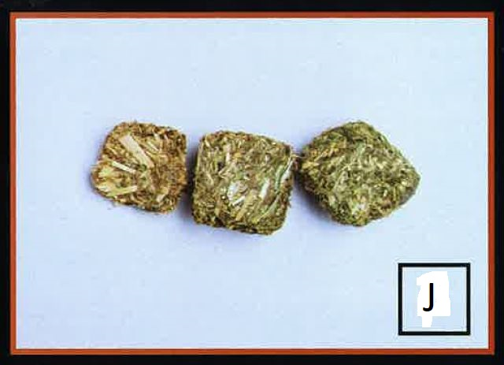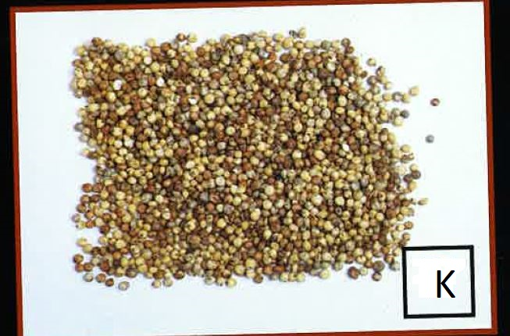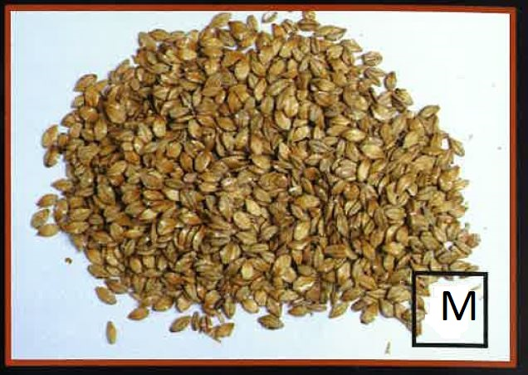
Cracked corn Hay cubes Milo Steam rolled barley
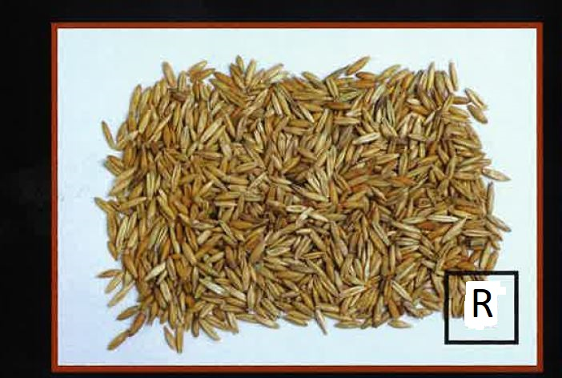 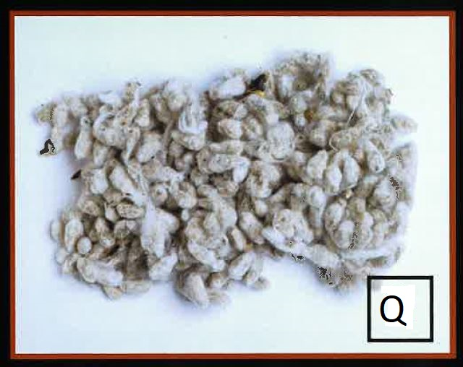
Whole grain oats Whole cottonseeds

