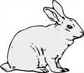
Jackson County 4-H Skill-A-Thon
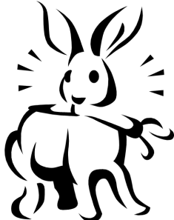
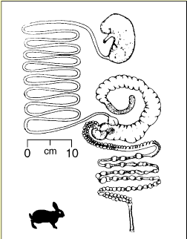
2020 RABBIT STUDY GUIDE

Uses of Rabbit Breeds:

Breeding Stock Meat Production Fur
Wool Laboratory Use Pets
Name the different types of hair:

DID YOU KNOW: Rabbits cannot live on lettuce and carrots alone! Too much lettuce will cause fatal
Diarrhea in rabbits.

Rabbit Digestive Tract

A doe and her litter will drink about a gallon of water a day!
6 essential nutrients for rabbits
Protein Fat Carbohydrates Vitamins Minerals WATER
“What one do you think is the most important?

A rabbit has 5 toes on the front feet and 4 on the back feet.

Rabbit Class Systems

Small: 2-6 pounds mature size. These compact size rabbits make good pets or show rabbits

Medium: 6-9 pounds mature size. These are often multipurpose breeds used for showing, wool production and as pets.

Large: 9-11 pounds mature size. This class includes many commercial meat production breeds used for marketing and show purposes.

Giant: Over 11 pounds. These giant rabbits require more space.


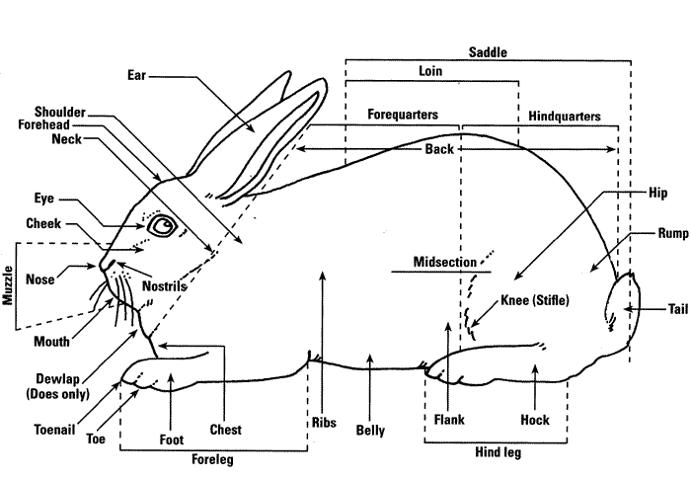
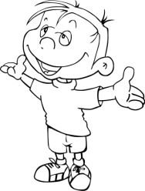
Parts of a
Rabbit
It is important to be able to identify
the parts of your
4-H animals. Study this picture and practice identifying the parts.

DID YOU KNOW: A rabbit is the only animal that will produce 10 times its own
weight in one year.

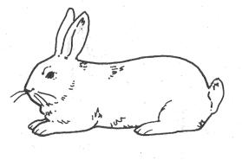
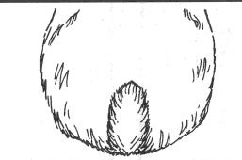
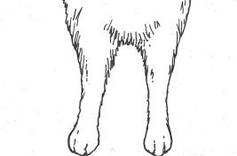
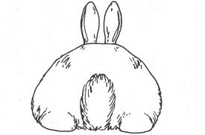
Rabbit Conformation

Ideal Ears Ideal Tail Ideal Legs Ideal Hips
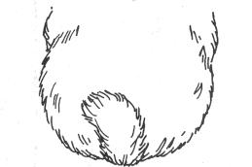
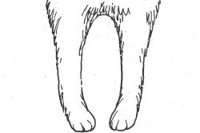
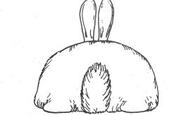
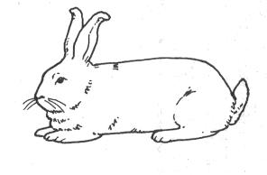

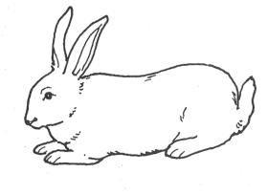
Belled Ears Side Carried Tail Inward-Bowed Legs Rough Hips

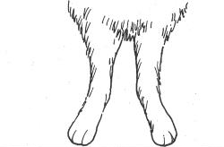
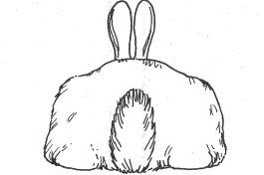
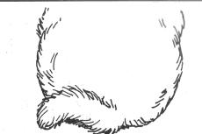
Open Carried Ears Screw Tail Outward-Bowed Legs Not Enough Rise



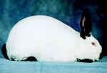
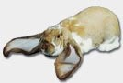
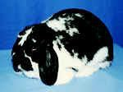
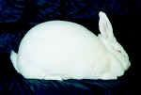
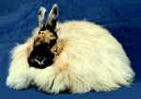
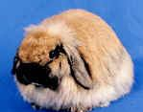





Knowing the names and a few characteristic of
different breeds of rabbits are important.

Match the breeds of rabbits with the pictures.
California: This large, commercial breed originated in the United States. Coat color is white with colored ears, feet, tail and nose. Point color is chocolate or black. Mature weight ranges from 8-10 ½ pounds. It has good fur quality, is popular for show and bred for meat.

English Lop: This large, English breed has a semi-arch
A. type profile. Ears are carried low on head with no
noticeable crown. They are at least 21 inches from tip to
tip. Fur is medium length, fine and silky. Mature weight is 9 pounds and over.

B. Mini Lop: This small, compact breed originated in Germany as a sub-breed of English Lop. Body is massive and thick set. Fur is glossy, medium length, thick and dense. Mature weight ranges from 4 ½ to 6 ½ pounds. It has a good meat and fur quality and is popular for show.
C.
New Zealand: This large, commercial breed originated in
the United States. Varieties include black, red and white. Fur is fly back. Mature weight ranges from 10-11
pounds. This breed exemplifies meat production.

D. English Angora: This is a medium wool breed, with a compact type profile. It originated in England. Coat is a silky texture with guard hairs protecting the undercoat. Coat color is rich with many varieties. Mature weight
E. ranges from 5 to 7 ½ pounds.

American Fuzzy Lop: This small, compact breed originated in the United States. Wool is dense, slightly
F. coarse, appears in a variety of colors and is evenly coved with guard hairs. Mature weight is 3-4 pounds.

3 | P a g e

Know the names and a few characteristic of different breeds of cattle:
Angus: These animals are polled (no horns) with a black coat. They are know for their carcass quality, milking and mothering and their reproductive traits. They are the most popular breed of cattle in the United stated.
Herford; These animals are red with white faces and
can be polled or horned. They were brought the United Stated in 1817. They became popular due to their hardiness, feed efficiency and disposition.
Simmental: Charolais Gelbvieh Limousin

Definitions:
Bull: Male animal
Heifer: Female animal that has not yet calved
Steer: Castrated male
Fattening: The process of deposition energy in the form of
fat within the body tissue
Gestation: The length of time an animal is pregnant Cud: The bolus of eaten feed which is regurgitated and further chewed.
Expenses: items that you have purchased for your project
Profit: when your income is larger than your expenses Loss: when your expenses are larger than your income
Breakeven: The price per pound you need to cover your total expenses
Intravenous-applying medication for the benefit of the animal directly into the blood flow
Subcutaneous: Applying medication for the benefit of the
animal under the skin
Intramusclar: applying medication for the benefit of the
animal into the muscle

Rabbit Ailments & Disorders

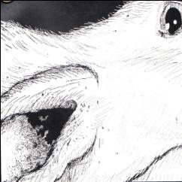
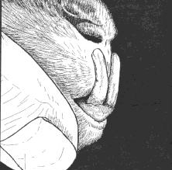
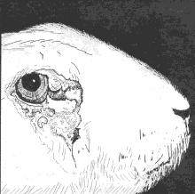
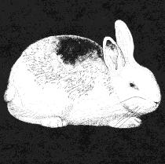
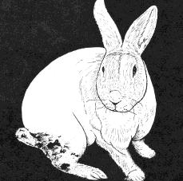

Coccidiosis Ear Canker Malocclusion Weepy Eye Mange

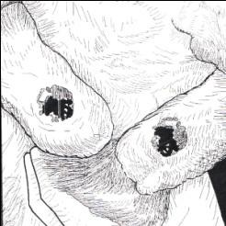
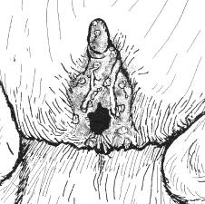
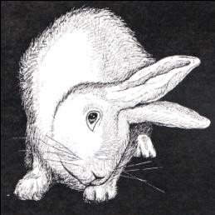
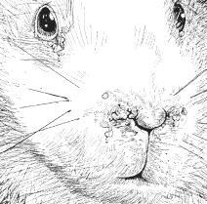

Snuffles Sore Hocks Vent Disease Wry Neck
Animal Health
It is very important to be able to monitor the health of your animal, know your vet and be able to properly treat the animal as needed.
- Never give medication to your animal without a vet, parent or 4-H leader.
- To properly give medication to animals you must be able to understand the medication label.
Be able to identify:
  - Name of drug
  - Name of distributor
  - Storage information
  - Withdrawal times
  - Quantity of content
  - Active ingredients
  - Cautions and Warnings

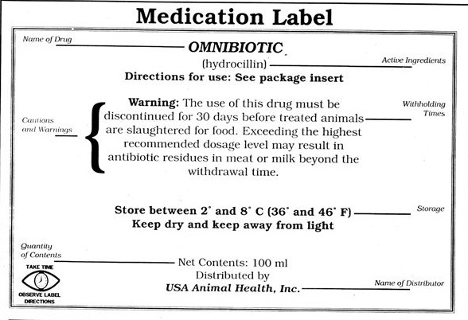

Feeds

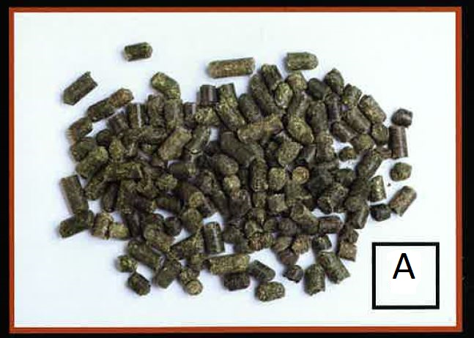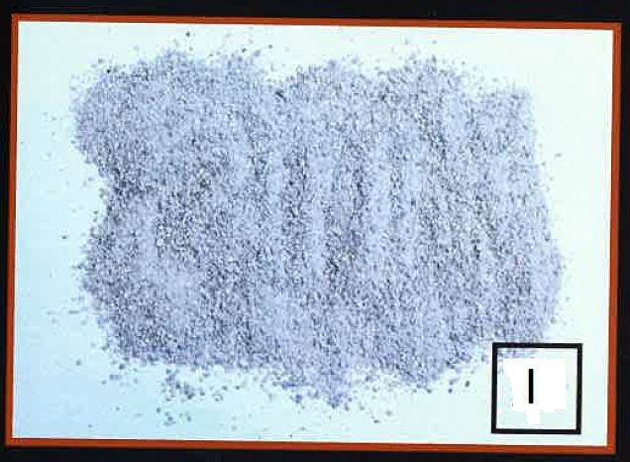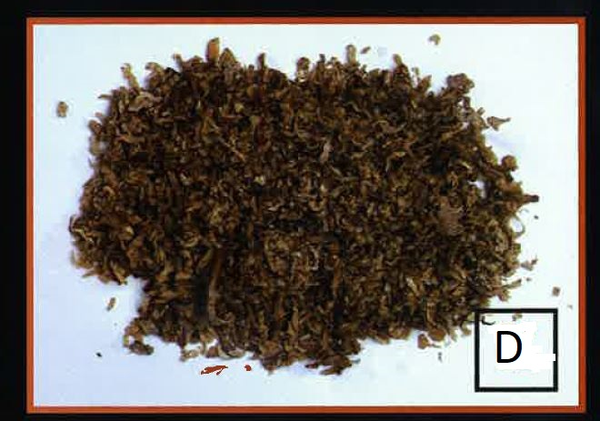
Alfalfa pellets ground limestone beet pulp

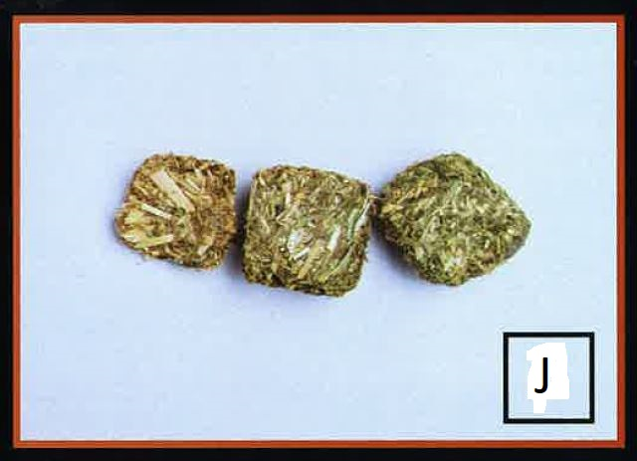 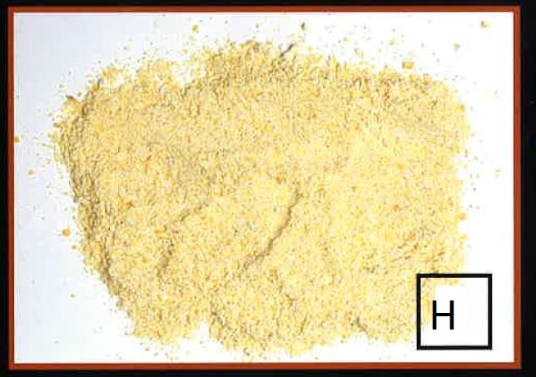 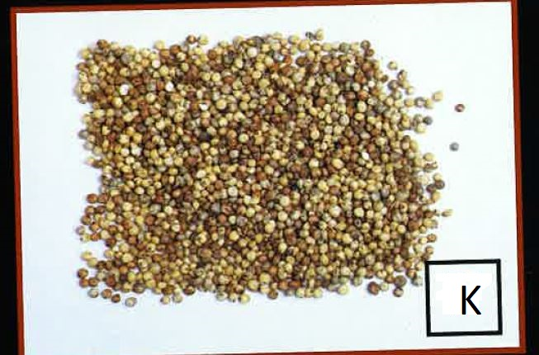
Hay cube Ground corn Milo

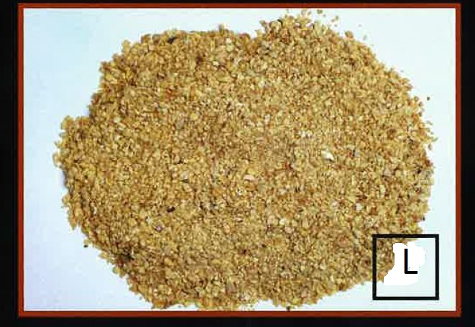 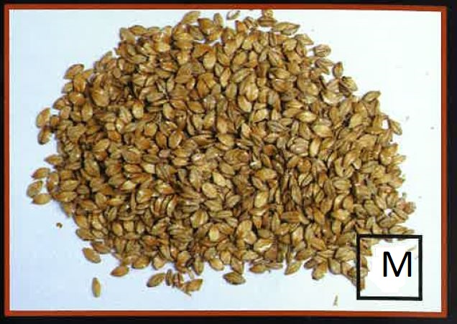 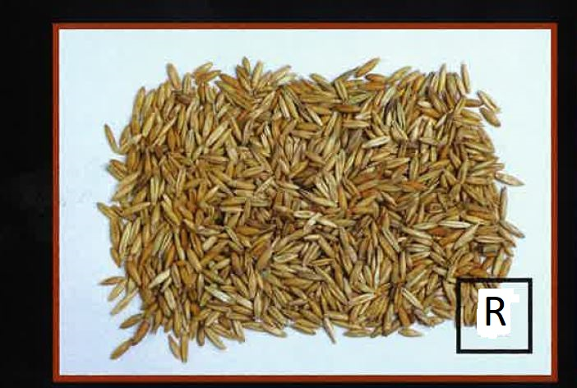
Soybean meal Steam rolled barley whole grain oats

Definitions:
Roughage: High fiber low energy feeds (example: hay) Concentrates: High energy low fiber feeds (example: corn) Conformation: The shape and design of an animal
Junior Doe: A female that has not had a litter
Buck: Male animal Doe: Female animal Kit: A new baby rabbit
Kindling: A female rabbit giving birth to a litter of kits Gestation: The length of time a mother carries her litter Molt: Act of shedding or changing fur
Colostrum: the first milk that a kit gets from its mother. It is rich in nutrients and antibodies
Fattening: the process of depositing energy in the form of fat within the body
tissue
Dressing Percent: the amount of lean meat on a carcass. The more meat the higher the cutability
Breakeven price: the price per pound you need to cover your total expenses Pedigree Record- The family tree of each individual rabbit that shows sires and dams.
Immunity: the ability to resist infection.

