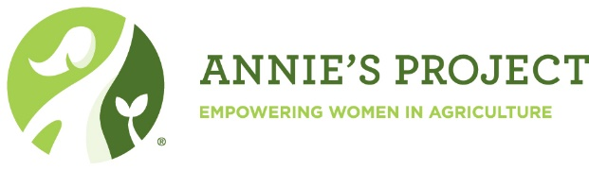

**Farm and Ranch Women are Decision Makers**

The decisions made today have a long-range impact on all businesses.

Farm and ranch women are generating a cultural tide in American agriculture that is moving management, assets and opportunities to a new wave of farmers across the country.

Whether new or experienced, understanding the five areas of agricultural risk, knowing how to analyze agricultural spreadsheets and other necessary skills are vital.

At Annie’s Project they are learned in a friendly environment where questions and discussion are welcome and allow the learning process to flourish.

**Why Annie's Project?**

This six-week course is a discussion-based workshop bringing women together to learn from experts in production, financial management, human resources, marketing and the legal field.

There's plenty of time for questions, sharing, reacting and connecting with your presenters and fellow participants.

It's a relaxed, fun and dynamic way to learn, grow and meet other ranch women.

Empowering farm women to be better business partners through networks and by managing and organizing critical information.

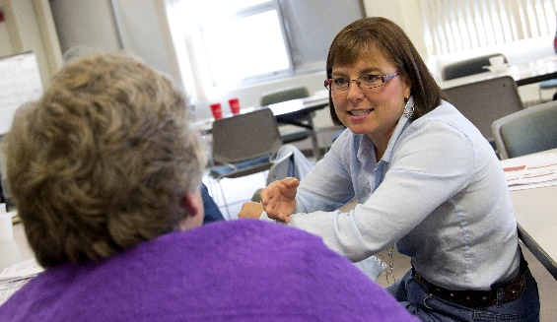

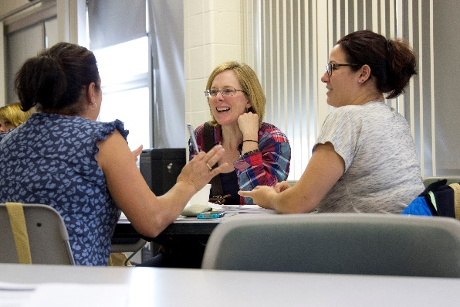

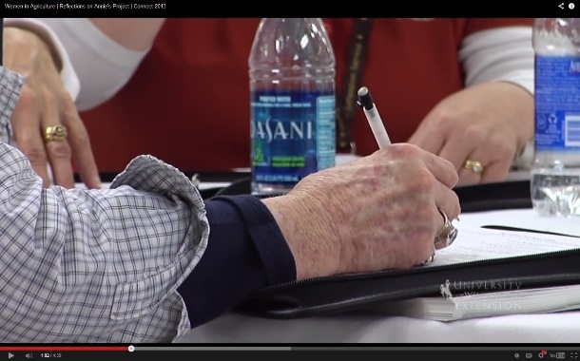

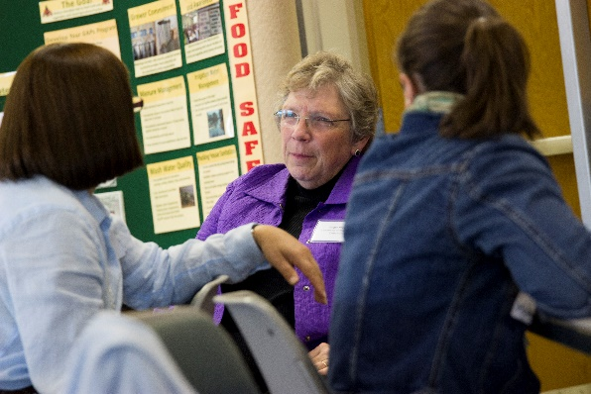

For more information call Aleigh Aurin at 970-723-4298 or e-mail aleigh.aurin@colostate.edu

Every Other Thursday Evening from 6-9 pm

North Park School

Walden, CO

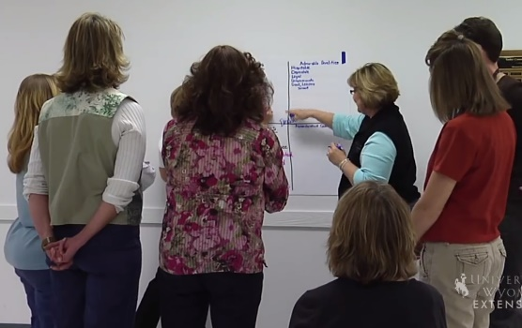

**Annie’s Alumnae Speak Out**

*“Annie’s Project gave me connections, increased my knowledge about the business end of farming which I knew nothing about. It was a place to ask questions and learn….it was a wonderful experience! The instructors were absolutely wonderful. They are knowledgeable, they are helpful, they are genuinely invested in the people they work with.” – Suzanne*

*“I grew up on the family farm for 21 years, but today’s way of farming is much different. As my father would say, ‘It’s a sophisticated business.’ I needed to learn more so I could be an effective member of a team in the areas of marketing and finances. I have learned about the future of farming and have been given a variety of tools that will help my father currently and my husband farm in the future.”  
 – Carrie*

✂

**Registration Form**

Name: _____________________________________

Address: _____________________________________

City, State, Zip: _____________________________________

E-mail

_____________________________________

(E-mail addresses will be used for internal record keeping only – never sold.)

**Registration deadline: 10/1/2020**

Clip and return by with $70 enrollment fee made payable to CSU Extension

CSU Extension

312 5th Street

Walden, CO 80480

You may also register online by emailing aleigh.aurin@colostate.edu

Enrollment is limited to facilitate discussion. Registration will be accepted on a first-come basis.

**Schedule of Topics**

**October 8th**

* Overview and Introductions
* Human resources – Real Colors

**October 22nd**

* Estate Planning
* Insurance for Farm Families
* Basic Financial Documents

**November 5th**

* Farm Leasing
* Interpretation of Financial documents
* Livestock marketing

**November 19th**

* Web Soil Survey
* NRCS
* Livestock Insurance

**December 3rd**

* Farm Service Agency
* Enterprise Analysis
* Women and Money

**December 17th**

* Hiring and Management
* Other topics of interest
* What have we learned

**North Park CattleWomen**